

COURSE NAME
Information Security Lab
Assignment No: 08
Submitted To: Ma’am Sadaf Ayub
Submitted By: Spogmai Jan
2430-0081
DEPARTMENT OF Computer Science
SIR SYED CASE INSTITUTE OF TECHNOLOGY, ISLAMABAD



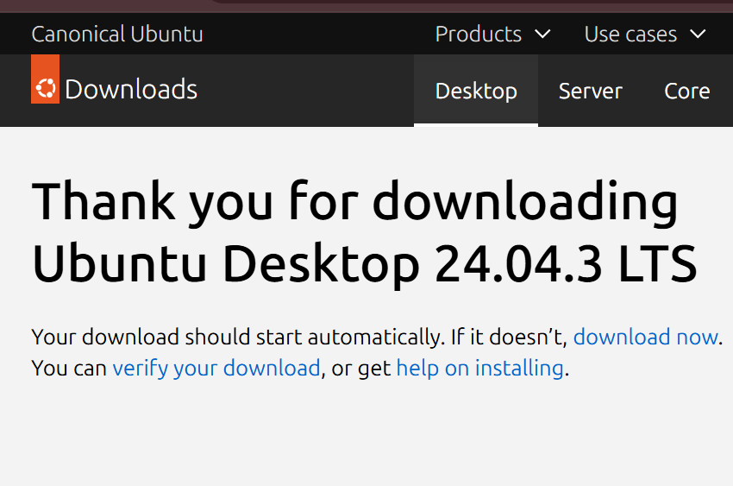



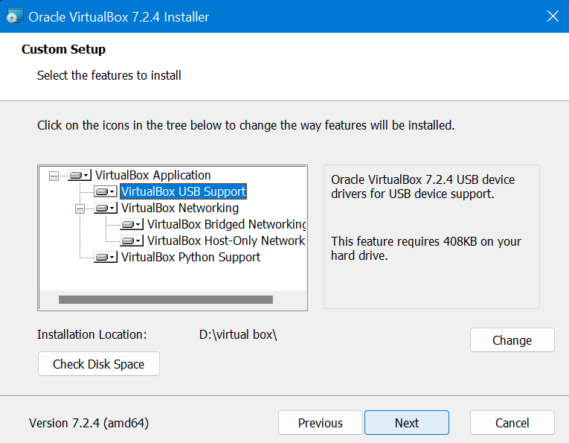


Conclusion:
Due to an error, I couldn’t continue and finish the task.

==================================================

